Design The Reddit API

Design an API for Reddit subreddits given the following information.

The API includes these 2 entities:

* **User** | *userId: string*, ...
* **SubReddit** | *subredditId: string*, ...

Both of these entities likely have other fields, but for the purpose of this question, those other fields aren't needed.

Your API should support the basic functionality of a subreddit on Reddit.

*Many systems design questions are intentionally left very vague and are literally given in the form of `Design Foobar`. It's your job to ask clarifying questions to better understand the system that you have to build.*

*We've laid out some of these questions below; their answers should give you some guidance on the problem. Before looking at them, we encourage you to take few minutes to think about what questions you'd ask in a real interview.*

**Question 1**

Q: To make sure that we're on the same page: a subreddit is an online community where users can write posts, comment on posts, upvote / downvote posts, share posts, report posts, become moderators, etc..--is this correct, and are we designing all of this functionality?

A: Yes, that's correct, but let's keep things simple and focus only on writing posts, writing comments, and upvoting / downvoting. You can forget about all of the auxiliary features like sharing, reporting, moderating, etc..

**Question 2**

Q: So we're really focusing on the very narrow but core aspect of a subreddit: writing posts, commenting on them, and voting on them.

A: Yes.

**Question 3**

Q: I'm thinking of defining the schemas for the main entities that live within a subreddit and then defining their CRUD operations -- methods like Create/Get/Edit/Delete/List<Entity> -- is this in line with what you're asking me to do?

A: Yes, and make sure to include method signatures -- what each method takes in and what each method returns. Also include the types of each argument.

**Question 4**

Q: The entities that I've identified are Posts, Comments, and Votes (upvotes and downvotes). Does this seem accurate?

A: Yes. These are the 3 core entities that you should be defining and whose APIs you're designing.

**Question 5**

Q: Is there any other functionality of a subreddit that we should design?

A: Yes, you should also allow people to award posts. Awards are a special currency that can be bought for real money and gifted to comments and posts. Users can buy some quantity of awards in exchange for real money, and they can give awards to posts and comments (one award per post / comment).

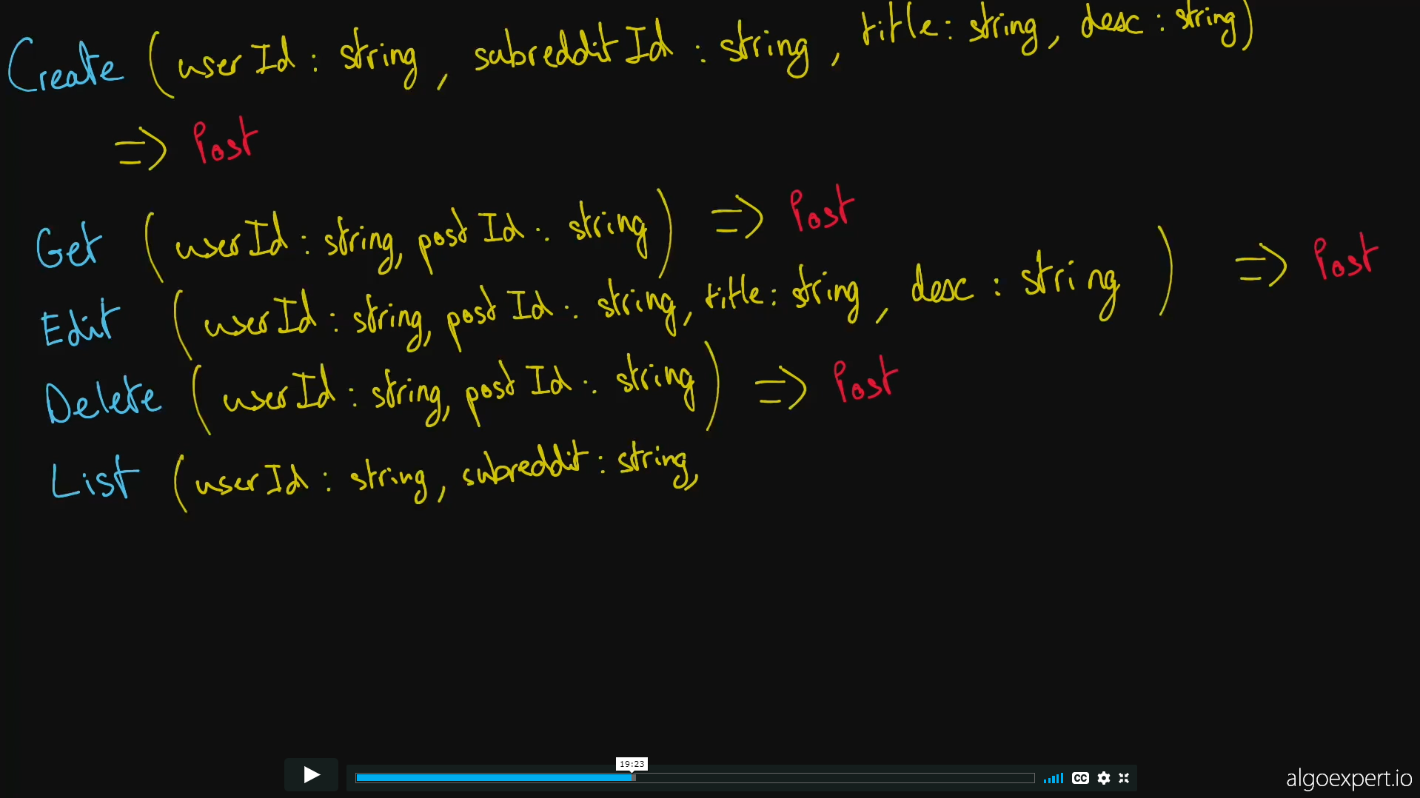

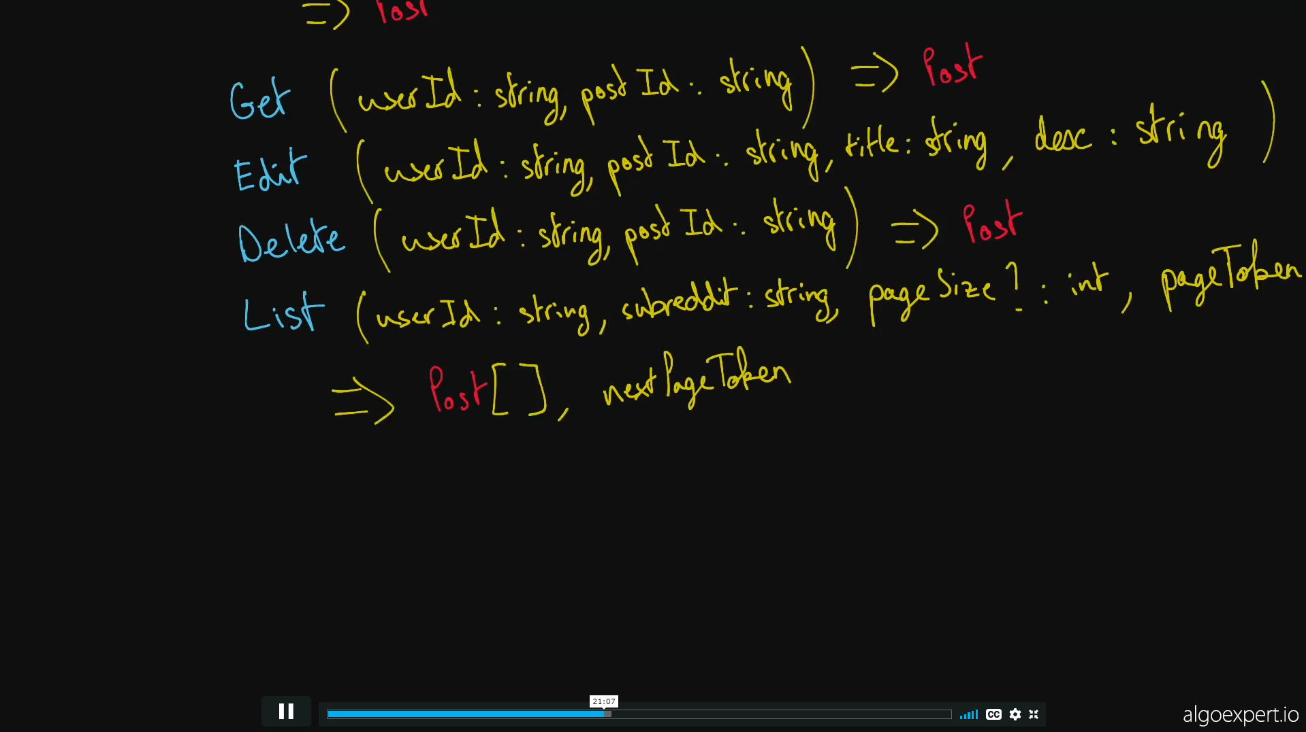

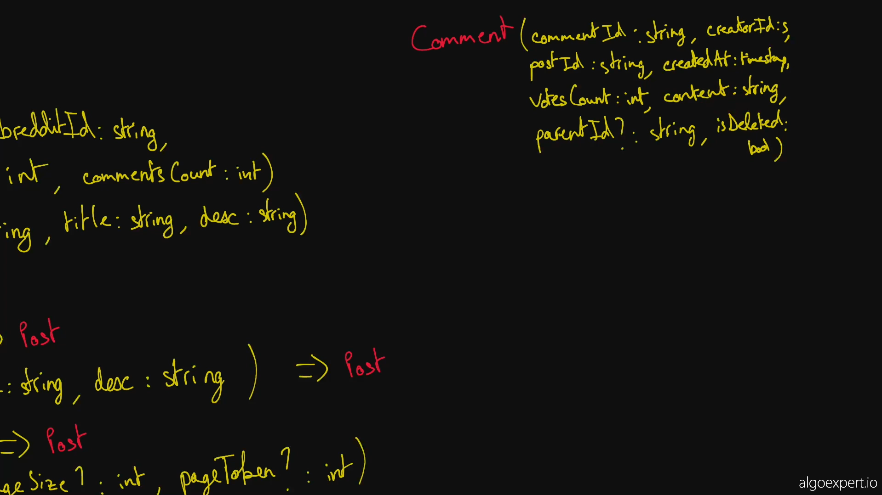

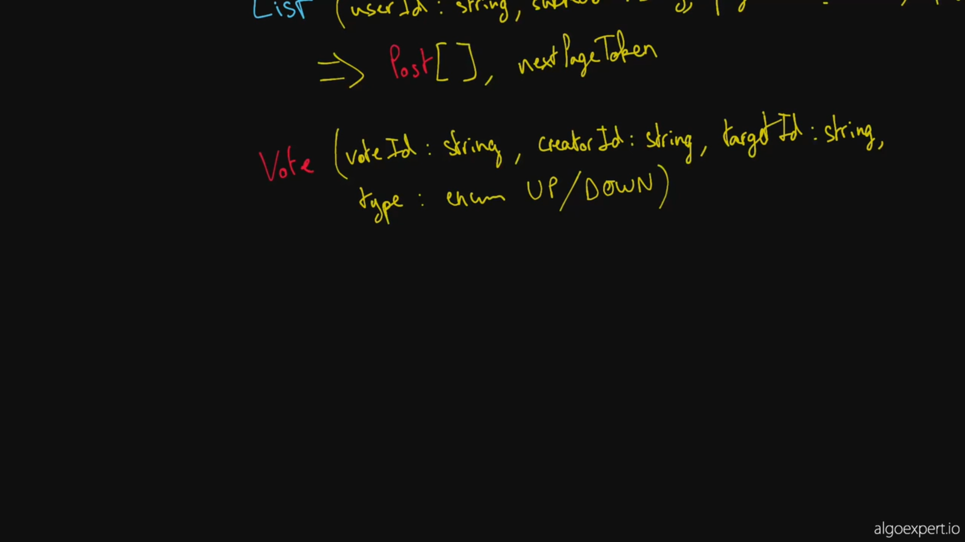

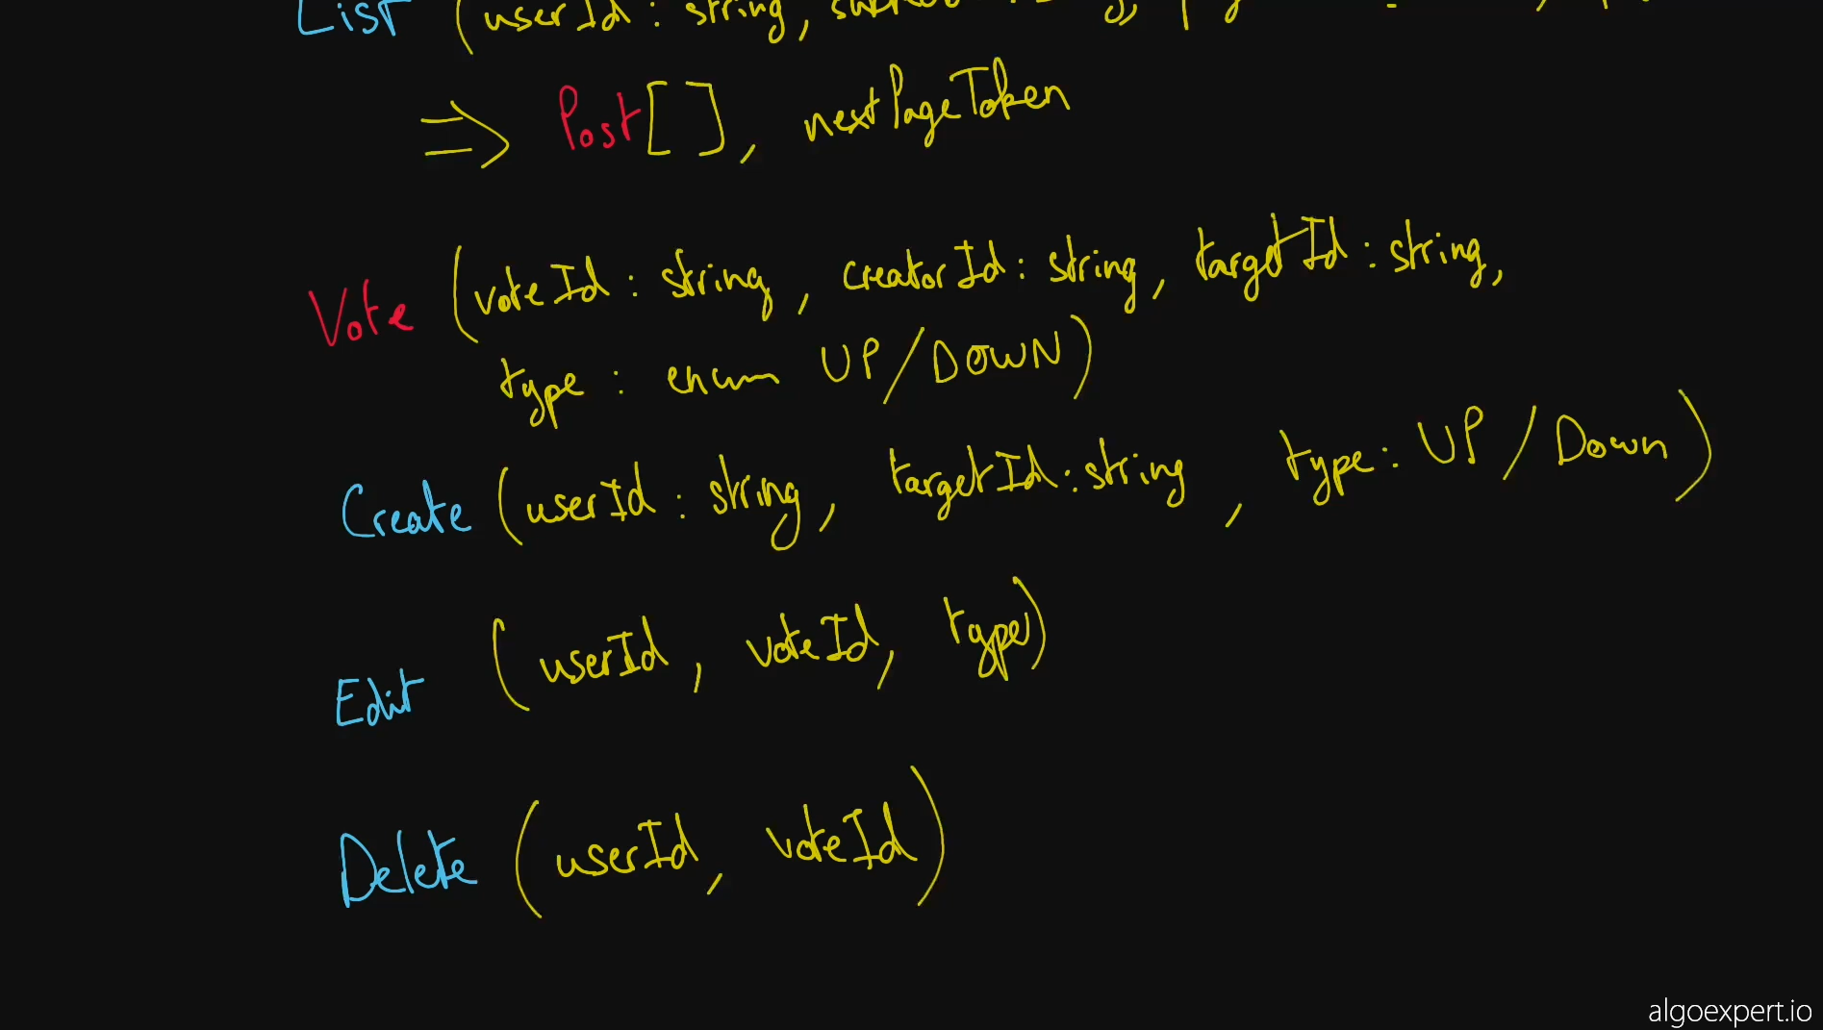

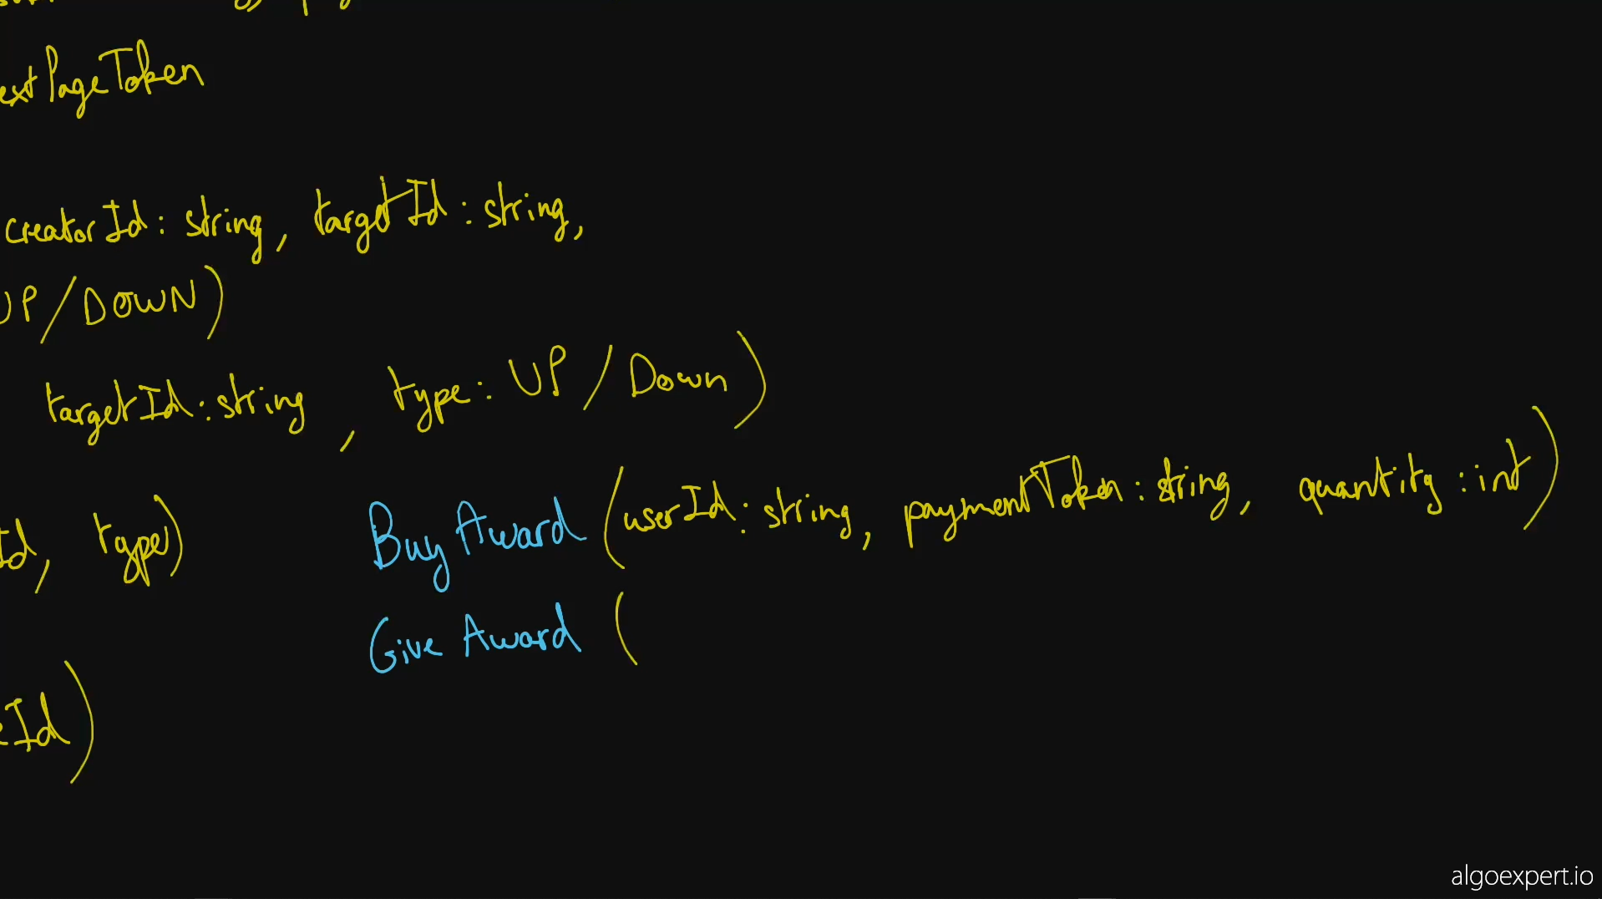

Our solution walkthroughs are meant to supplement our video solutions. We recommend starting with the video solution and using the walkthrough either as a point of reference while you watch the video or as a review tool if you need to brush up on this question's solution later on.

**1. Gathering Requirements**

As with any API design interview question, the first thing that we want to do is to gather API requirements; we need to figure out what API we're building exactly.

We're designing the core user flow of the subreddit functionality on Reddit. Users can write posts on subreddits, they can comment on posts, and they can upvote / downvote posts and comments.

We're going to be defining three primary entities: Posts, Comments, and Votes, as well as their respective CRUD operations.

We're also going to be designing an API for buying and giving awards on Reddit.

**2. Coming Up With A Plan**

It's important to organize ourselves and to lay out a clear plan regarding how we're going to tackle our design. What are the major, potentially contentious parts of our API? Why are we making certain design decisions?

The first major point of contention is whether to store votes only on Comments and Posts, and to cast votes by calling the EditComment and EditPost methods, or whether to store them as entirely separate entities--siblings of Posts and Comments, so to speak. Storing them as separate entities makes it much more straightforward to edit or remove a particular user's votes (by just calling EditVote, for instance), so we'll go with this approach.

We can then plan to tackle Posts, Comments, and Votes in this order, since they'll likely share some common structure.

**3. Posts**

Posts will have an id, the id of their creator (i.e., the user who writes them), the id of the subreddit that they're on, a description and a title, and a timestamp of when they're created.

Posts will also have a count of their votes, comments, and awards, to be displayed on the UI. We can imagine that some backend service will be calculating or updating these numbers when some of the Comment, Vote, and Award CRUD operations are performed.

Lastly, Posts will have optional deletedAt and currentVote fields. Subreddits display posts that have been removed with a special message; we can use the deletedAt field to accomplish this. The currentVote field will be used to display to a user whether or not they've cast a vote on a post. This field will likely be populated by the backend upon fetching Posts or when casting Votes.

postId: string

creatorId: string

subredditId: string

title: string

description: string

createdAt: timestamp

votesCount: int

commentsCount: int

awardsCount: int

deletedAt?: timestamp

currentVote?: enum UP/DOWN

Our CreatePost, EditPost, GetPost, and DeletePost methods will be very straightforward. One thing to note, however, is that all of these operations will take in the userId of the user performing them; this id, which will likely contain authentication information, will be used for ACL checks to see if the user performing the operations has the necessary permission(s) to do so.

CreatePost(userId: string, subredditId: string, title: string, description: string)

=> Post

EditPost(userId: string, postId: string, title: string, description: string)

=> Post

GetPost(userId: string, postId: string)

=> Post

DeletePost(userId: string, postId: string)

=> Post

Since we can expect to have hundreds, if not thousands, of posts on a given subreddit, our ListPosts method will have to be paginated. The method will take in optional pageSize and pageToken parameters and will return a list of posts of at most length pageSize as well as a nextPageToken--the token to be fed to the method to retrieve the next page of posts.

ListPosts(userId: string, subredditId: string, pageSize?: int, pageToken?: string)

=> (Post[], nextPageToken?)

**4. Comments**

Commments will be similar to Posts. They'll have an id, the id of their creator (i.e., the user who writes them), the id of the post that they're on, a content string, and the same other fields as Posts have. The only difference is that Comments will also have an optional parentId pointing to the parent post or parent comment of the comment. This id will allow the Reddit UI to reconstruct Comment trees to properly display (indent) replies. The UI can also sort comments within a reply thread by their createdAt timestamps or by their votesCount.

commentId: string

creatorId: string

postId: string

createdAt: timestamp

content: string

votesCount: int

awardsCount: int

parentId?: string

deletedAt?: timestamp

currentVote?: enum UP/DOWN

Our CRUD operations for Comments will be very similar to those for Posts, except that the CreateComment method will also take in an optional parentId pointing to the comment that it's replying to, if relevant.

CreateComment(userId: string, postId: string, content: string, parentId?: string)

=> Comment

EditComment(userId: string, commentId: string, content: string)

=> Comment

GetComment(userId: string, commentId: string)

=> Comment

DeleteComment(userId: string, commentId: string)

=> Comment

ListComments(userId: string, postId: string, pageSize?: int, pageToken?: string)

=> (Comment[], nextPageToken?)

**5. Votes**

Votes will have an id, the id of their creator (i.e., user who casts them), the id of their target (i.e., the post or comment that they're on), and a type, which will be a simple UP/DOWN enum. They could also have a createdAt timestamp for good measure.

voteId: string

creatorId: string

targetId: string

type: enum UP/DOWN

createdAt: timestamp

Since it doesn't seem like getting a single vote or listing votes would be very useful for our feature, we'll skip designing those endpoints (though they would be straightforward).

Our CreateVote, EditVote, and DeleteVote methods will be simple and useful. The CreateVote method will be used when a user casts a new vote on a post or comment; the EditVote method will be used when a user has already cast a vote on a post or comment and casts the opposite vote on that same post or comment; and the DeleteVote method will be used when a user has already cast a vote on a post or comment and just removes that same vote.

CreateVote(userId: string, targetId: string, type: enum UP/DOWN)

=> Vote

EditVote(userId: string, voteId: string, type: enum UP/DOWN)

=> Vote

DeleteVote(userId: string, voteId: string)

=> Vote

**6. Awards**

We can define two simple endpoints to handle buying and giving awards. The endpoint to buy awards will take in a paymentToken, which will be a string that contains all of the necessary information to process a payment. The endpoint to give an award will take in a targetId, which will be the id of the post or comment that the award is being given to.

BuyAwards(userId: string, paymentToken: string, quantity: int)

GiveAward(userId: string, targetId: string)